ENEE 3720, FALL 2017

Design Project

**Amplifier Circuit Design using the Instrumentation Amplifier**

December 5, 2017

Adam Bell

Group Member: John Kondor

Objective

The objective of this project was to design an instrumentation amplifier for a transducer in a bridge circuit. From the circuit designed an output voltage of +/- 5V is to be produced when the resistance R5 deviated by +/- 10% from the resistor value of R4.

Specifications

Table 1: Design Specifications

|  |  |
| --- | --- |
| **Project Specification and Components** | |
| **Component** | **Quantity** |
| 10V DC Power Supply | 1 |
| 15V DC Power Supply | 2 |
| Protoboard | 1 |
| Breadboard | 1 |
| 10K ohm resistor | 9 |
| 5.1 V Zener Diode 5010A | 1 |
| 33 Ohm Resistor | 1 |
| 39 Ohm Resistor | 1 |
| 2K Ohm Potentiometer | 1 |
| NTE941M Operational Amplifier | 4 |
| Soldering Iron with solder wire | 1 |
| Pack of jump wires | 1 |

Design Approach/Design Circuit

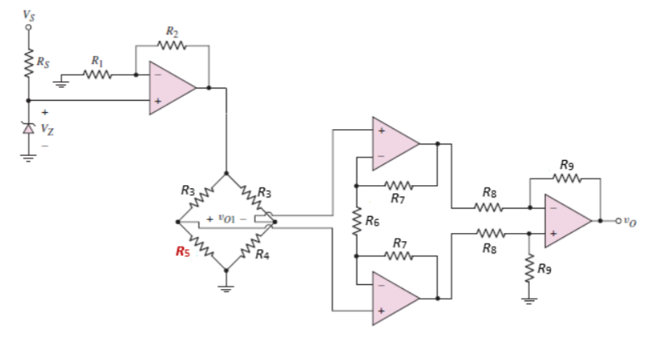

Figure 1: Instrumentation amplifier circuit

Choices/Assumptions

Some of the assumptions made about the circuit were that the zener diode will regulate voltage supplied to the circuit after a certain input voltage was reached. After browsing through common zener diodes that were available to buy, we decided to pick out values for the resistors that would work with a 5.1V zener diode in mind. So, Vinput=Vzener=5.1V. After realizing this, the rest of the circuit could be analyzed in pieces.

Solution Method

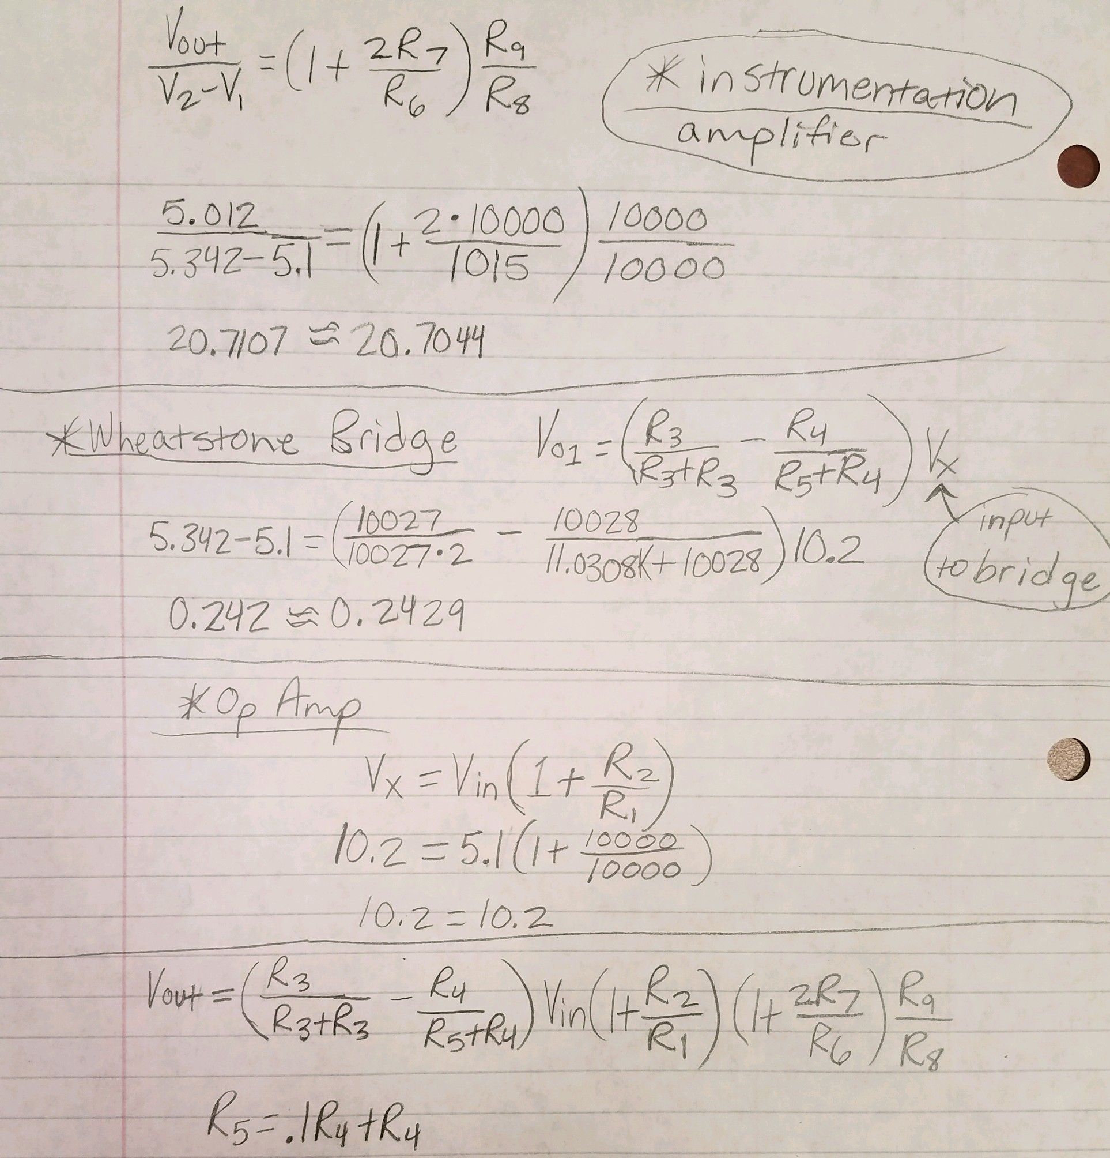

Above are set of equations relating the input voltage of each part of the circuit to its respective output voltage.The equation for an instrumentation op amp is listed first, then a wheatstone bridge, then an inverting op amp (with power supply on the positive terminal, and lastly an equation that combines the previous equations to produce an equation for Vout based on resistor values and the beginning Vin (which is equal to Vz when the diode is on). The voltage results from Pspice and the actual resistance values used were plugged into these equations to ensure correctness.

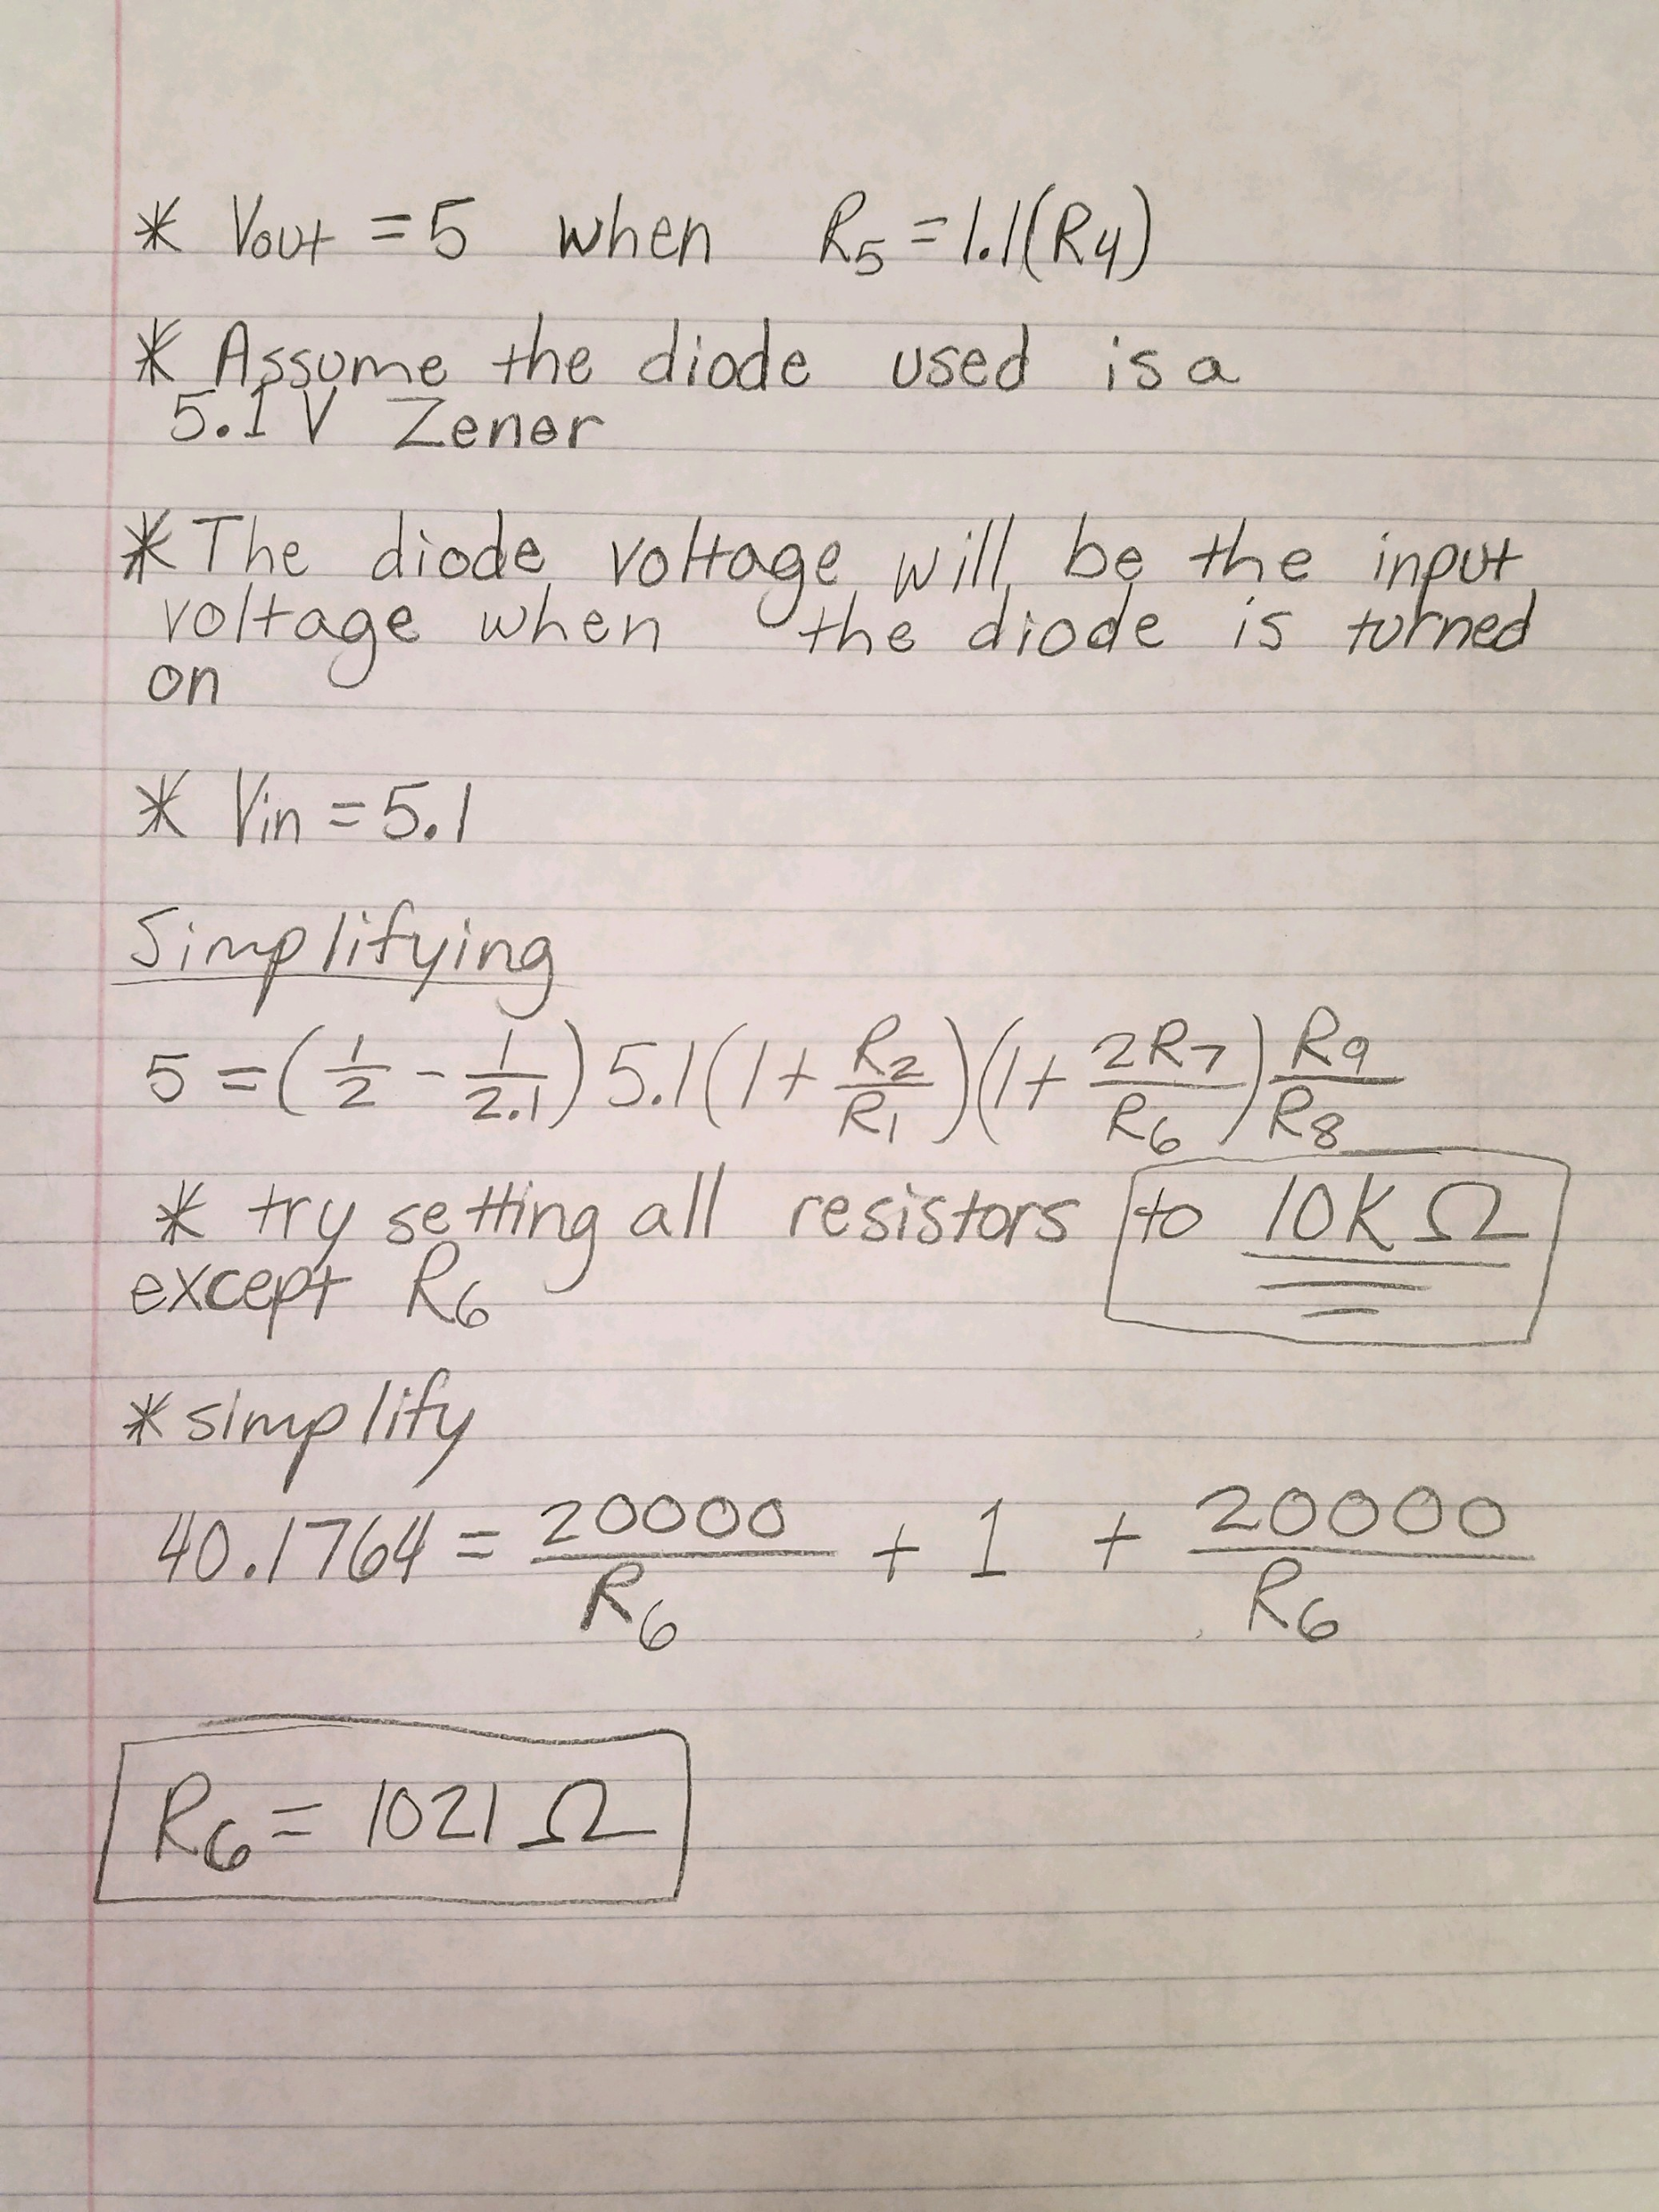

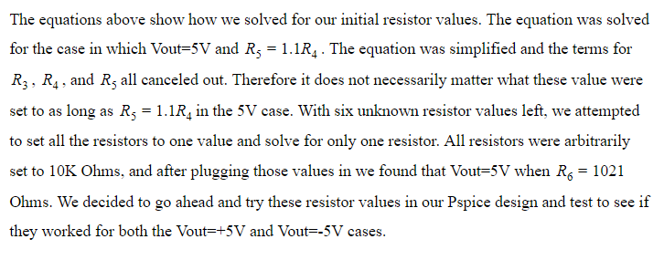

Pspice Simulation Results Summary

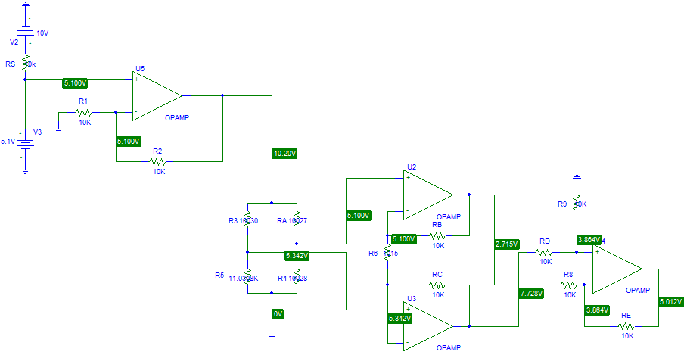

Figure 2: Pspice simulation of instrumentation amplifier with **5.012 V** output.

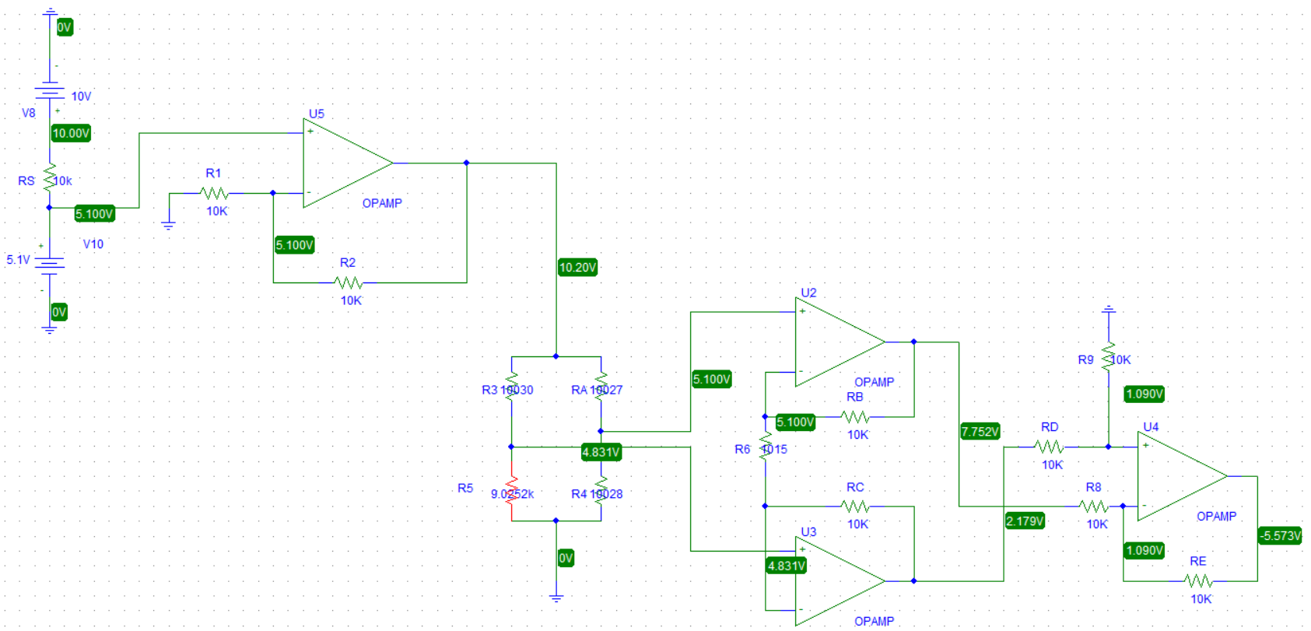

Figure 3: Pspice simulation of instrumentation amplifier with -**5.573 V** output.

The voltage entering the circuit was chosen to be **10 V** and the voltage across the zener diode was chosen to be **5.1 V**. In this Pspice simulation we used a battery source to take place of the zener diode. We did this because Pspice didn’t have a zener diode where the voltage was adjustable to **5.1V**. To make the math easier we used 10K ohm resistors across the whole circuit except for the transducer R5 and the resistor R6 that varied. To power each operational amplifier +/- 15 V was used, and as a result we obtained an output roughly +/- **5.0 V**. The actual measured values of the resistors used in the wheatstone bridge were plugged into the circuit because it was found that small deviations in these values heavily influenced the output. The actual value of $R_{6}$ used was $R_{6}=1015$ Ohms rather than 1021 Ohms because that was the closest valued resistor available that still gave desired results. Although the voltage was slightly off for the negative case, we decided to proceed with building the breadboard circuit.